Meet the Teacher

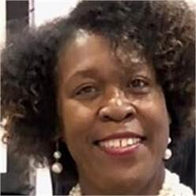

My name is Mary Camp and I will have the pleasure of teaching your child this school year. I believe in education. I am committed to it and to creating a positive learning environment. Teaching, to me, is an opportunity to inspire and empower. My husband retired from the Air Force. We have three children and two grandchildren. We live in Harlem and enjoy the quiet country life. I am excited to make this the best school year yet!

Mrs. Camp

Contact Me: Education:

My education includes a Bachelor’s Degree in Elementary Education, a Master’s in Counseling, and a Specialist in Curriculum and Instruction. I am also certified to teach Gifted students.

I love to hear from parents throughout the year. Please always contact me with questions or concern. 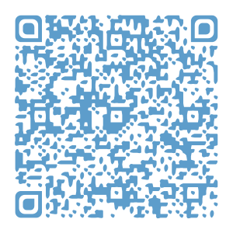Please scan the QR code to download my contact information into your cell phone.

My Favorites:

## Store: Walmart

## Food: Any Fruit

## Hobby: Reading

## Candy: Chocolate with nuts

## Fast Food: Chick Fil A

## Flower: Peonies or Tulips

## Drink: Water Fuji

Scent: Aromatherapy Stress Relief

Season: Spring

IIlo